Improved Fictive Packet Heuristic (IFP)

First, we sort all of the packets into the categories that are most relevant to them. Afterwards, we make use of $L_{i}$ in order to make a total of the estimated transmission time $t_{j}$, for all of the packets that fall under category $C_{i}$. After that, we take the categories and arrange them in a manner that is not ascending in the order of their $L_{i}$. One fictitious packet will be used to represent each category, and the new projected transmission time will be denoted by the letter $L_{i}$. Following the completion of the first stage, the packets are arranged in each category according to the projected transmission order that does not increase. A threshold value, denoted by Ts, is unchangeable. threshold is determined by the following formula: Ts= $\frac{\sum_{j=1}^{np}{t_{j}}}{2}$ packets are comprised of In the event that the total expected time spent in the router Ro does not go over Ts, we scheduled on the router Ro. Otherwise, packets are scheduled on router Ro2.

Algorithm (IFP)

|  |
| --- |
| 1: Call DFP(Pa, Ci)  2: Call DECRS(FPa)  3: Calculate Ts  4: while (k ≤ $n_{c}$ and ∑ ($L_{k}$) ≤Ts) do  5: Calculate ${ct}_{k}^{1}$ 6: end while  7: while (k ≤ $n_{c}$) do  8: Calculate ${ct}_{k}^{2}$ 9: end while  10: Calculate Tmax  11: Return Tmax |

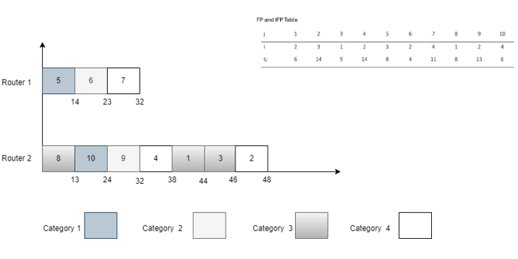

Example:

Packets:

j: [1,2,3,4,5,6,7,8,9,10]

i: [2,3,1.2,3,2,4,1,2,4]

tj: [6,14,9,14,8,4,11,8,13,6]

Step 1: Range Packets into categories

Category 1: [7]

Category 1.2: [3]

Category 2: [1, 5, 8]

Category 3: [2, 4, 9]

Category 4: [6, 10]

Step 2: Calculate category

L1 = 11

L1.2 = 9

L2 = 28

L3 = 37

L4 = 20

Step 3: Sorting categories

Categories sorted based on:

1. Category 3 (L3 = 37)

2. Category 2 (L2 = 28)

3. Category 4 (L4 = 20)

4. Category 1 (L1 = 11)

5. Category 1.2 (L1.2 = 9)

Step 4: Create creative packets

Each category should be represented as a fictive packet, and the new predicted transmission time should be denoted by the symbol ${ L}_{i}$.

Step 5: Packets are sorted inside categories

Each category's packets have already been sorted after being sorted.

Step 6: Calculate threshold

Ts = (6 + 14 + 9 + 14 + 8 + 4 + 11 + 8 + 13 + 6) / 2 = 83 / 2 = 41.5

Step 7: schedule packets.

* It is necessary to create two empty queues for Router Ro and Router Ro2 in order to begin functioning.
* In order to ensure that the total projected time in Router Ro does not exceed Ts, it is highly recommended to schedule packets.
* With regard to any categories that are still available, packets are scheduled to be sent on Router 2 Ro2.

Step 8: Determine the maximum amount of time required to finish anything.

Determine Tmax by using the schedules of packets on both routers as a basis for the calculation procedure.

Step 9: Return  (Tmax)

Give back the maximum amount of time that can be spent finishing the task.